Name:
Tutor group:

Summer work
In preparation For Year 8 Science
Term 1
This workbook contains exam questions, checklist, success criteria and condensed notes work covered in Year 7
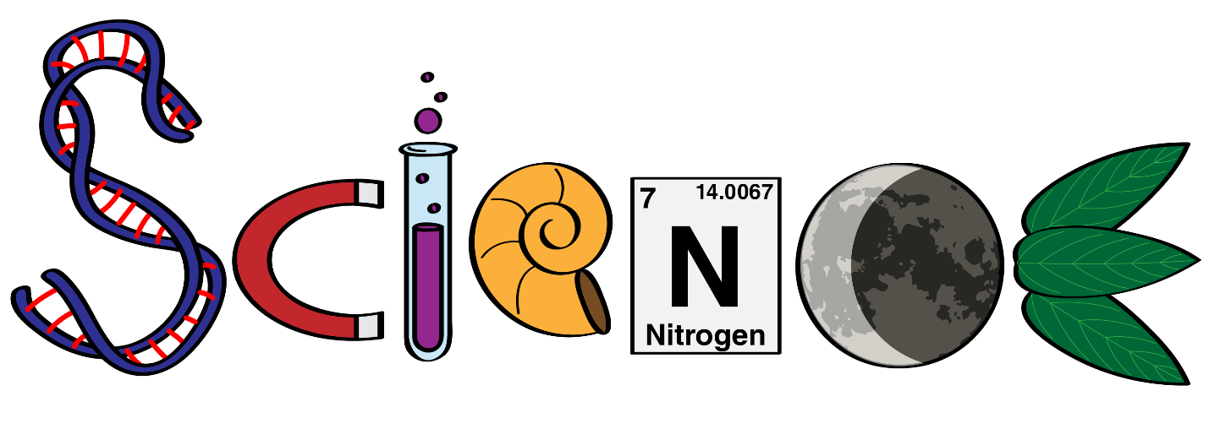

Year 8 revision guidelines
You will be examined on the topic that you have studied this year that is Cells & Their Processes, Acids & Alkalis and Forces
Read the guidelines in the document called How to Revise Science for some general advice on good revision strategies.
Condensed notes for each topic are included in this pack. These contain the bare minimum of what you are expected to remember from each topic. You can use these as a starting point when making your own notes. You must use the notes that you make in class along with the text book.
Complete all of the Revision question sheets included in this pack
You can check that you remember all the Science keyword definitions and equations by testing yourself using the apps such as Quizlet.
Parts of the syllabus to be revised:
- Cells & Their Processes
- Acids & Alkalis
- Forces
These topics can be found in the booklet uploaded on Edmodo.

Preparing for the Term 1 Science exam
- Find the Exploring Science Syllabus summary sheets attached (7A, 7E, 7K)
  - Write a note or draw a diagram to illustrate (answer) every single syllabus point from the summary sheet. Use your text book and exercise book to help you.
  - Include examples of how to answer questions;
- When you have finished the notes use them to make a second draft. It is important not to just copy the text book – think hard about what it means and put it into your own words.
- Now your notes are in your own words make one last version – challenge yourself to write the shortest sentences and turn most of it into diagrams.
- Using other revision books is no substitute for writing your own notes – it is the act of writing in your own words and diagrams that synthesises and embeds the knowledge, as well as confirming to you that you really do understand it. More importantly – if you can’t write a short note it tells you that you don’t really understand it yet!
- At the end of each set of notes for a topic do practice questions. There are unused exam questions in the text book at the end of each chapter, and in the Science Workbook.

Cells and their Processes
Use the notes in your workbook and your Y7 workbook to help you revise this unit and complete the questions. This will help you prepare for the year 8 baseline test in September 2019.
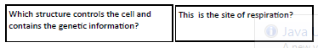
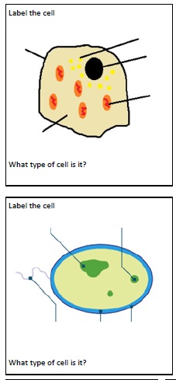
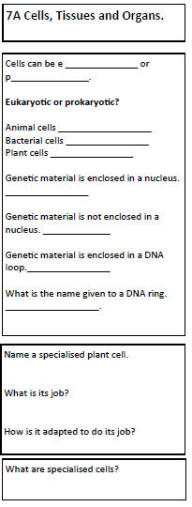
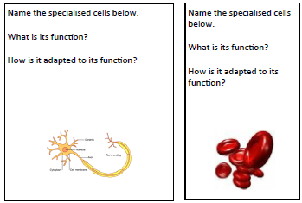
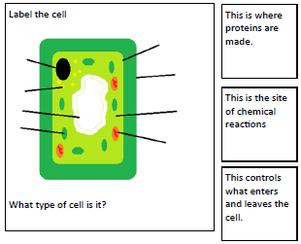

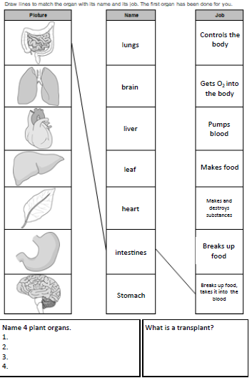

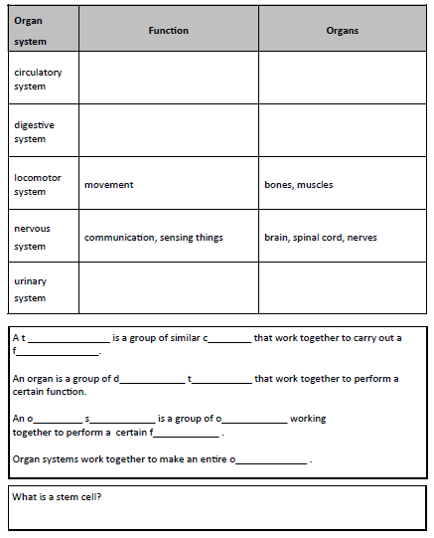

Acids & Alkali – Revision
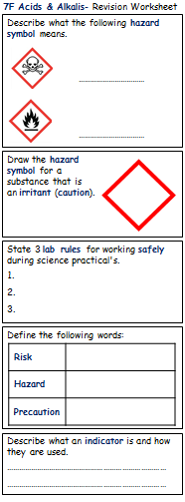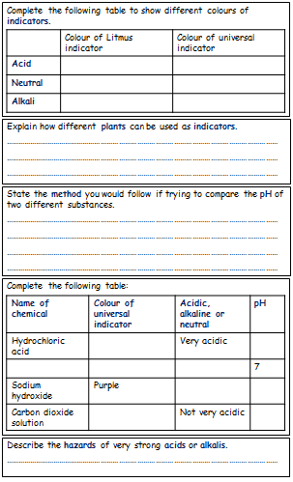

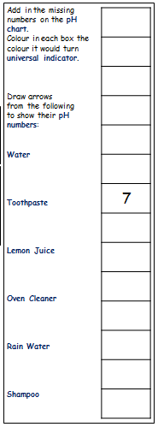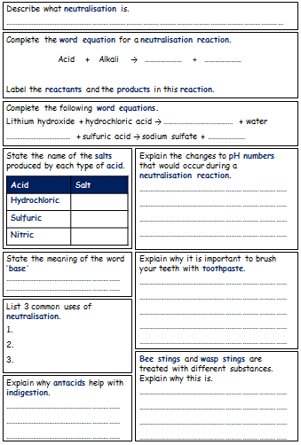

Forces Revision Questions
