Name:
Tutor group:

Summer work
Forces, pressure and moments work booklet
Year 10 Physics
Terms 1, 2 and 3
This workbook contains exam questions, checklist, success criteria and condensed notes on topics 1-5
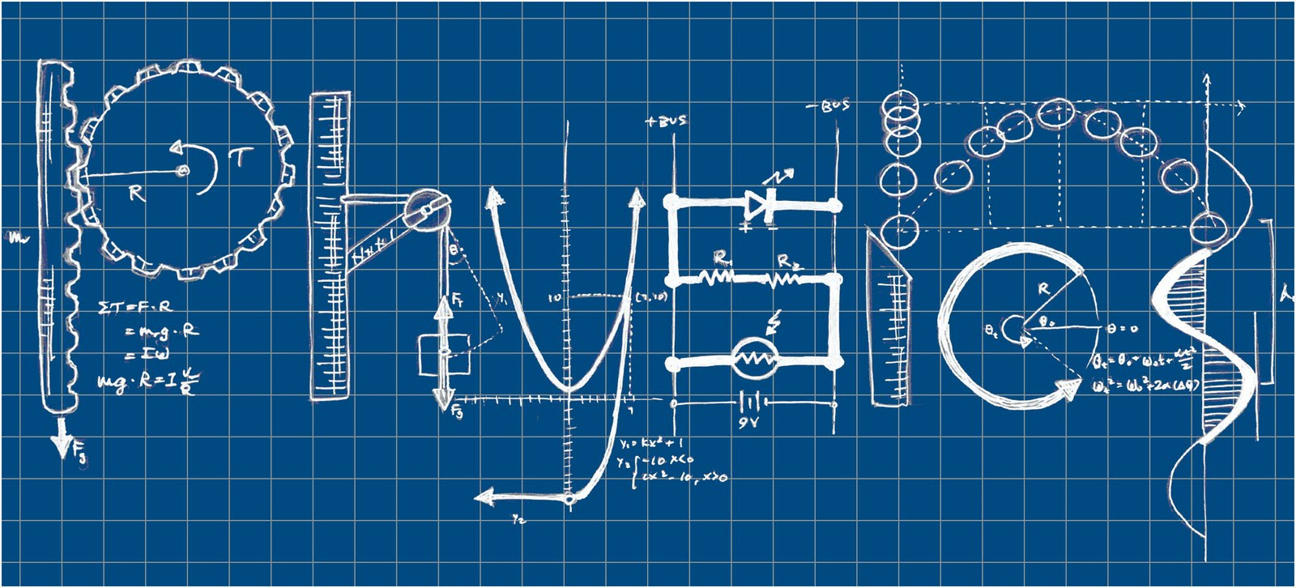

Year 10 IGCSE Physics revision guidelines
You will be examined on all of the Physics you have studied this year, up to and including the Optics topic.
Read the guidelines in the document called How to Revise Physics (LIG) for some general advice on good revision strategies.
There are documents called Condensed notes for each topic in this pack. These contain the bare minimum of what you are expected to remember from each topic. You can use these as a starting point when making your own notes. You must use the notes that you make in class along with the text book.
Please refer to the document on in this pack that contains a checklist of all the things you need to know for the end of year test. The document goes all the way to the end of Year 11 so just complete it as far as the end of Year 10.
If you have not already done so, complete all of the Revision question sheets
You can check that you remember all the Physics keyword definitions and equations by testing yourself using the Quizlet quizzes that can be found on edmodo.
Parts of the syllabus to be revised:
- Graphs and Measurements
- Forces
- Energy and power
- Thermal Physics
These topics are covered in your Physics textbook chapters 1-5

Preparing for the End of Year Exam in Physics
- Find the Cambridge Syllabus that was given to you at the beginning of the year.
  - Write a note or draw a diagram to illustrate (answer) every single syllabus point. Use your text book and exercise book to help you.
  - Include examples of how to answer questions;
- When you have finished the notes use them to make a second draft. It is important not to just copy the text book – think hard about what it means and put it into your own words.
- Now your notes are in your own words make one last version – challenge yourself to write the shortest sentences and turn most of it into diagrams.
- Using other revision books is no substitute for writing your own notes – it is the act of writing in your own words and diagrams that synthesises and embeds the knowledge, as well as confirming to you that you really do understand it. More importantly – if you can’t write a short note it tells you that you don’t really understand it yet!
- At the end of each set of notes for a topic do practice questions. There are unused exam questions in the text book at the end of each chapter, and in the Physics Workbook.

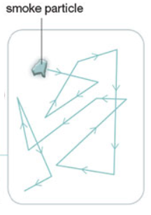
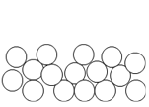
solid liquid gas

A thermocouple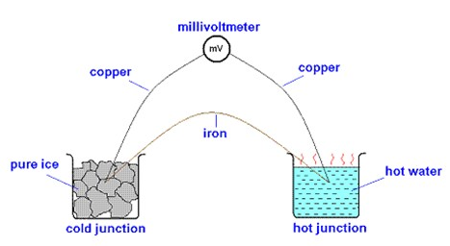
Evaporataion has a cooling effect because:
- The fastest particles escape from the surface of the liquid.
- The particles left behind are slower.
- Average speed of particles in the liquid has decreased so temperature decreased.
Evaporation happens at any temperature and particles only escape from the surface.
To increase the rate of evaporation: increase temperature, increase surface area, blow air over the surface of the liquid (a draught).

- When temperature increases, thermal expansion happens. This is because the particles move faster and become more spread out.
- The order of expansion from most to least: gases, liquids, solids.
- Fixed points are 0 °C and 100 °C.
- A thermometer can be made more sensitive by having a larger bulb or a narrower capillary/inner tube.
- Linearity requires a uniform diameter for the capillary/inner tube.
- Thermocouples are good for measuring rapidly changing and/or very high temperatures.

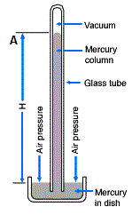  a barometer for measuring atmospheric pressure | 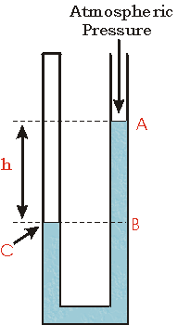  a manometer for measuring pressure differences

- Metals are good conductors because they have free electrons that transfer some kinetic energy inside the metal.
- In convection warm fluid rises as it has lower density, and colder fluid sinks as it has higher density.
- Black dull surfaces are the best emitters and absorbers of radiation.
- White shiny surfaces are the worst emitters and absorbers of radiation.

Pressure  p = $\frac{F}{A}$Pressure = $\frac{force}{area}$ | Pressure in fluids  p = ρgh  pressure = density x gravitational field strength x height
Manometer Δp = ρgΔh  pressure difference = density x gravitational field strength x height difference | Boyle’s law  pV = constant  pressure x volume = constant  p₁V₁ = p₂V₂
Specific heat capacity  E = mcΔT  Energy = mass x specific heat capacity x temperature change | Specific latent heat  E = mL  Energy = mass x specific latent heat

Quantity | Symbol | Unit
pressure | p | Pa or N/cm² (1 Pa = 10000 N/cm²)
area | A | m² or cm²
density | ρ | m
height/depth | h | m
gravitational field strength | g | m/s² or N/kg
volume | V | m³ or cm³
energy or heat | E or Q | J
temperature | T or θ | °C
specific heat capacity | c | J/kg°C
specific latent heat | L | J/kg
mass | m | kg

Energy conservation: energy cannot be created or destroyed but it can be converted from one type to another.

Examples of energy stores: gravitational potential energy, chemical energy, internal energy, nuclear energy, elastic strain energy, kinetic energy.

Examples of energy being transferred: light energy, sound energy, thermal, mechanical work, electrical work.

Energy resources are ways to generate electricity.
The sun is the source of almost all Earth’s energy resources. It causes the water cycle, causes winds and waves and the sun creates energy in food chains through photosynthesis. The energy stored in bio-matter can be turned into fuels. Energy resources that do not rely on the sun: tidal power, nuclear power and geothermal power.
Nuclear fusion is the process inside the sun that generates energy. It involves fusing small nuclei together to make larger nuclei. Nuclear fission happens inside nuclear power plants. This involves the splitting of a large nucleus into two smaller ones.
Renewable resources (solar, tidal, wind, waves, hydroelectric) will never run out.
Nonrenewable resources (fossil fuels, nuclear fuels) will eventually run out.

Energy resource | Advantages | Disadvantages
Solar power | Quiet.  No polluting gases emitted. | It’s not always sunny (night-time).  Uses a lot of space.
Wind power | Low maintenance costs.  No polluting gases emitted. | It’s not always windy.  Uses a lot of space.
Wave power | Low maintenance costs.  No polluting gases emitted. | It’s not always wavy.  Unattractive.
Hydroelectric power | Constant, predictable supply of electricity.  No polluting gases emitted. | Damages habitat by flooding land.  Requires construction of large dams.
Tidal power | Predictable supply of electricity.  No polluting gases emitted. | Damages habitat.  Requires construction of large turbines.
Geothermal power | Output can be controlled (predictable).  No polluting gases emitted. | Not many suitable sites.  Eventually the rocks cool down.
Coal, gas and oil | Output can be controlled.  Power stations can be built anywhere. | Produces polluting gases.  Extracting the fuels is dangerous.
Nuclear | Constant supply of electricity.  No polluting gases emitted. | Risk of nuclear accidents.  Storage of nuclear waste is difficult.

Kinetic energy  KE = ½ m v²  kinetic energy = half x mass x speed² | Momentum  p = mv  Momentum = mass x velocity
Gravitational potential energy  ΔGPE = mgΔh  Chance in GPE = mass x gravitational field strength x change in height | Work done (energy transferred)  W = ΔE = Fd  Work done = force x distance moved in direction of force
Power  P = $\frac{W}{t}$  Power = $\frac{Work done }{Time taken}$ | Efficiency is the proportion of the total energy that is converted into a useful form.  Efficiency = $\frac{useful energy output }{total energy input }$ x 100% Efficiency = $\frac{useful power output }{total power input }$ x 100%

Quantity | Symbol | Unit
Energy | E | J
Kinetic energy | KE | J
Gravitational potential energy | GPE | J
Work | W or ΔE | J
Power | P | W
Distance | d | m
Momentum | p | kg m/s

- Resultant force is the total force acting on an object.  - If there are two forces and they act in the same direction, add the forces together.  - If two forces act in opposite directions, subtract one from the other.  - When the resultant force is zero, an object stays at constant velocity or remains at rest (the acceleration = 0). | Scalar quantities have magnitude only. Examples: speed, mass, energy.  Vector quantities have magnitude and direction. Examples: velocity, force, acceleration.
A resultant force is required to make something move in a curved path or a circle. The force points towards the centre of the circle. The velocity is perpendicular to this force.

Momentum is always conserved in collisions. For two objects (m₁ and m₂) colliding, you can use:
m₁u₁ + m₂u₂ = m₁v₁ + m₂v₂
Impulse is change in momentum.

Moment is the turning effect of a force. In equilibrium (when balanced):
total clockwise = total anticlockwise
moments moments

The weight of an object appears to act from the centre of gravity of the object. This will produce a turning effect when the pivot is not below the centre of gravity.
moment of weight = weight x distance from centre of gravity to pivot.
A broken car is towed by two other cars as shown. Determine the magnitude and direction of the resultant force.

First decide a sensible scale, here we use 1 cm = 1000 N. Draw the two vectors the correct length and with the correct angle between them.

Draw a parallelogram by copying the two vectors on opposite sides as shown. You will need to use your protractor to get angles correct.

Draw in the resultant vector as the diagonal of the parallelogram. Use the arrows to help you decide which diagonal to choose. Use a ruler to measure the length and multiply it by your scale. Here: 10.8 x 1000 = 10800 N. The direction is the angle between the resultant and one of the sides. Here it is 8° from the 5000 N force.
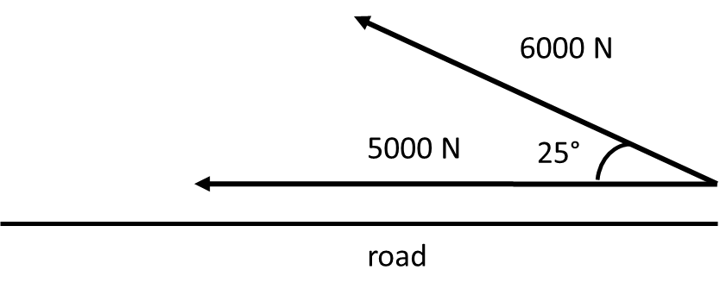
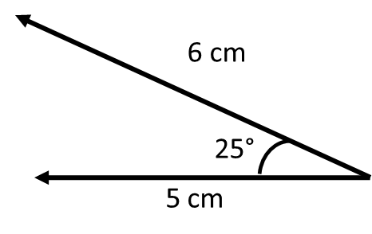
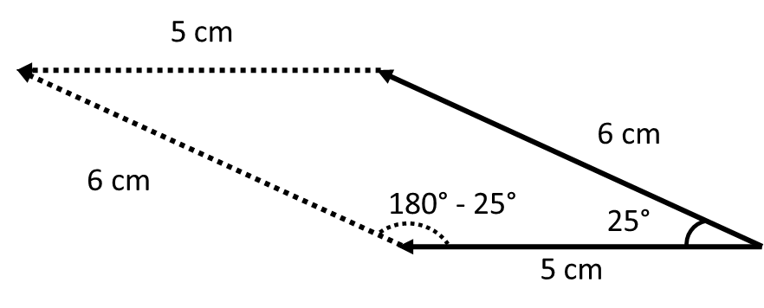
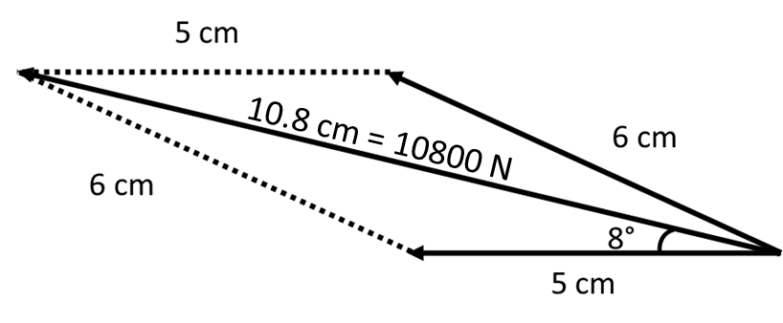
Resultant force (Newton’s 2nd law)  F = ma  Resultant force = mass x acceleration | Momentum  p = mv  Momentum = mass x velocity
Impulse*  Impulse = change in momentum  Impulse = force x time  Force x time = change in momentum  Ft = mv – mu | Moment  Moment is the turning effect of a force  Moment = force x perpendicular distance from pivot  If the distance is in cm, the unit of moment is Ncm. If the distance is in mm, the unit of moment is Nmm. If the distance is in m, the unit of moment is Nm.
*Note: impulse is confusing because there are two ways to calculate it. Make sure you understand both ways to calculate it and be ready to combine the equations.
Quantity | Symbol | Unit
Force | F | N
Weight | W | N

To determine average thickness of a sheet of paper, cut it into 20 small sheets, measure the thickness of all 20 sheets with a micrometer and divide by 20.
To determine average period of a pendulum, measure the time taken for 20 oscillations with a stopwatch and divide by 20.
To determine density of an irregular shape:
- Measure its mass with a balance
- Add some water to a measuring cylinder and measure its volume V₁
- Drop the object into the water and measure the new volume V₂
- Volume of object V = V₂ – V₁
- Use density = $\frac{mass}{volume}$

Gradient is steepness
Gradient = $\frac{Δy}{Δx}$ = $\frac{y_{2}- y_{1}}{x_{2}- x_{1}}$
A directly proportional graph is a straight line through the origin.
Weight is the force due to gravity.
Mass resists a change in motion.
Objects sink in a fluid if they are denser than the fluid.
Objects float in a fluid if they are less dense than the fluid.
Speed is the gradient of a distance-time graph.
Acceleration is the gradient of a speed-time graph.
Distance travelled is the area under a speed-time graph.
Hooke’s law  F = kx  Force = spring constant x extension  Force is directly proportional to extension. | Density  ρ = $\frac{m}{V}$  Density = $\frac{mass}{volume}$
Speed  v = $\frac{d}{t}$  Speed = $\frac{distance}{time}$ | Acceleration  a = $\frac{v - u}{t}$  Acceleration = $\frac{change in velocity}{time taken}$
Weight  W = mg  Weight = mass x gravitational field strength | Gravitational field strength on Earth = 10 N/kg  Acceleration due to gravity = 10 m/s²  All objects have the same acceleration due to gravity on Earth (10 m/s²)

Quantity | Symbol | Unit
Force | F | N
Weight | W | N
Extension | x | m (or cm or mm)
Spring constant | k | N/m (or N/cm or N/mm)
Mass | m | kg (or g)
Volume | V | m³ (or cm³)
Density | ρ | kg/m³ (or g/cm³)
Distance | d | m
Time | t | s
Speed | v | m/s
Acceleration | a | m/s²

Revision questions 2 - Forces
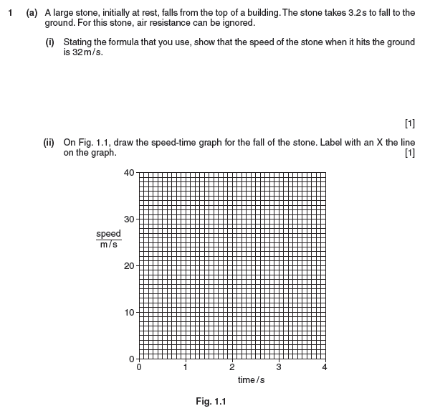
0625_m15_qp_32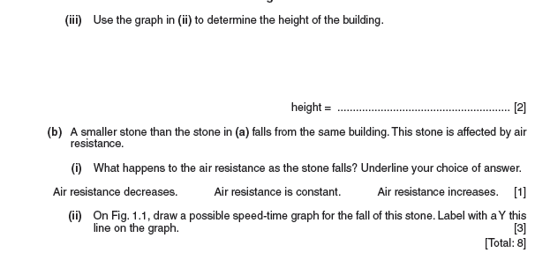
0625_s10_qp_31
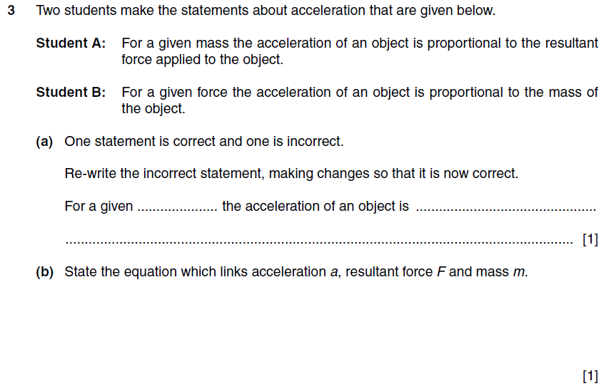
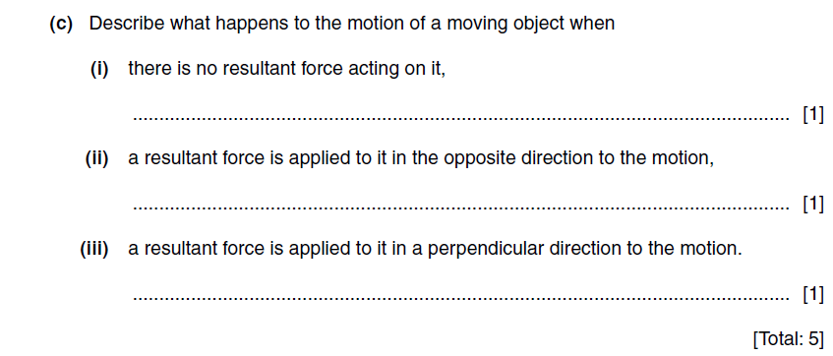

Revision questions 3 - Energy and power
0625_s06_qp_3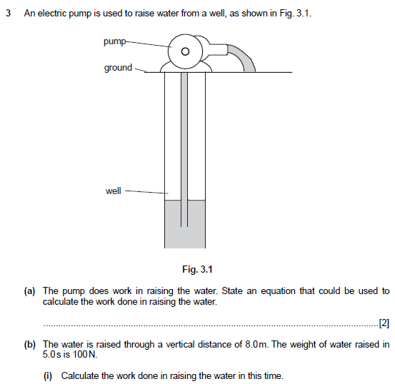
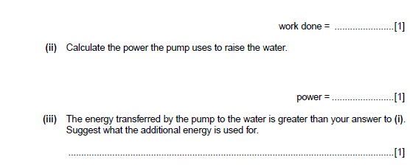

0625_s09_qp_3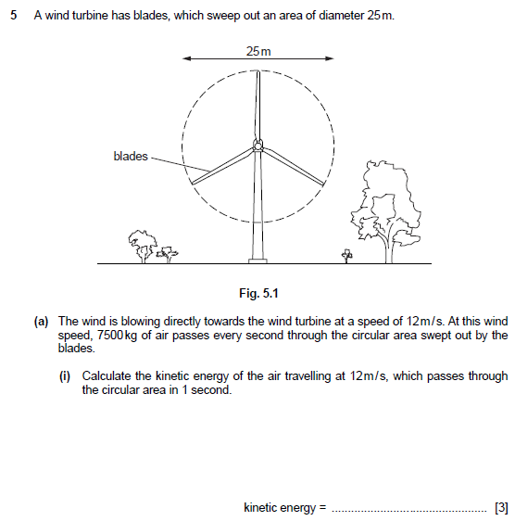
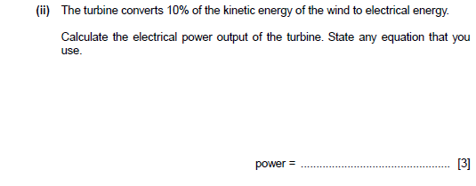
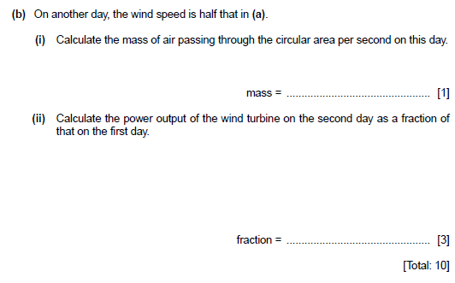

Revision questions 4 - Thermal physics
0625_w11_qp_31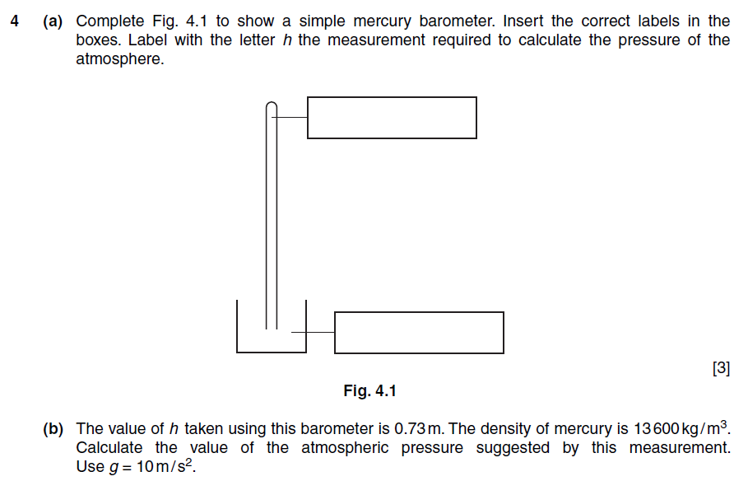

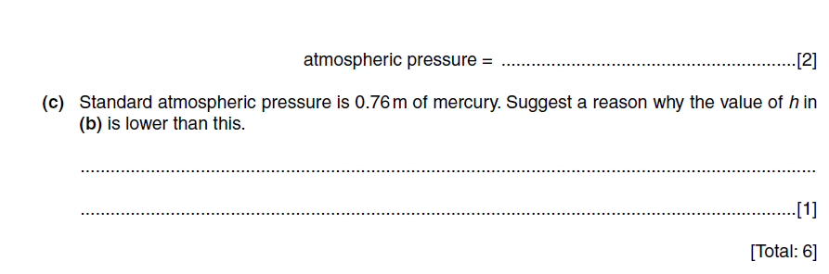

0625_s12_qp_31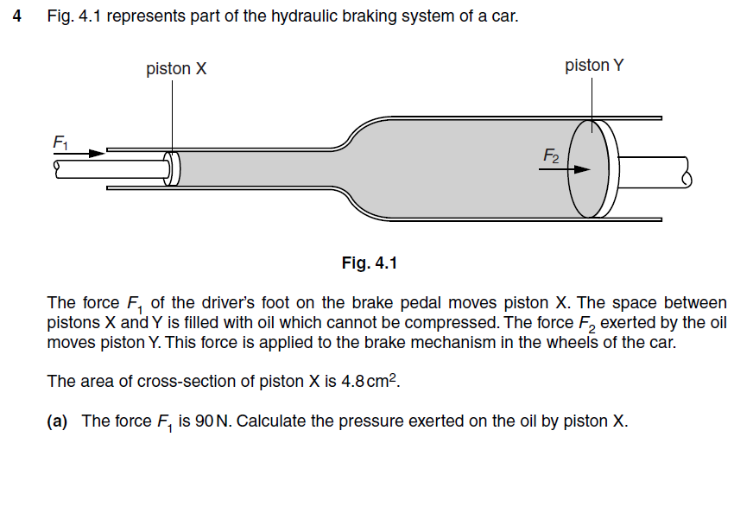
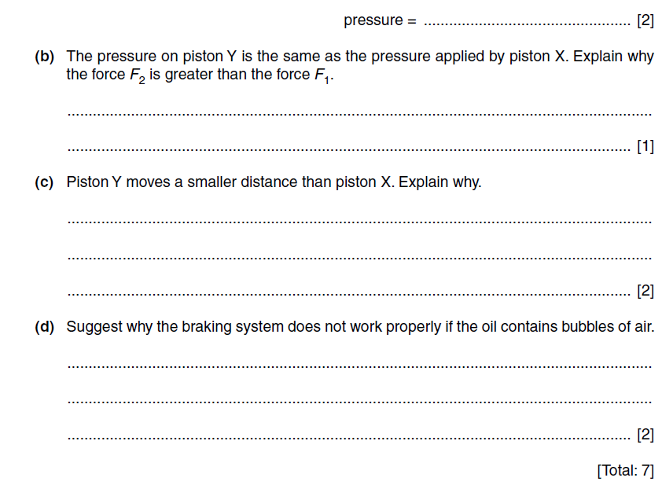
0625_s13_qp_32
