Name:
Tutor group:

Summer work
Year 10 Biology (Y9 student going to Y10)
Term 1
This workbook contains exam questions, checklist, success criteria and condensed notes on topics 1- 4

1 | Characteristics and Classification of living organisms.
2 | Size of specimens
3 | Energy flow and ecosystems
4 | Nutrient cycles

Preparing for the Exams in Biology
- Find the Cambridge Syllabus that was given to you at the beginning of the year.
  - Write a note or draw a diagram to illustrate (answer) every single syllabus point. Use your text book and exercise book to help you.
  - Include examples of how to answer questions;
- When you have finished the notes use them to make a second draft. It is important not to just copy the text book – think hard about what it means and put it into your own words.
- Now your notes are in your own words make one last version – challenge yourself to write the shortest sentences and turn most of it into diagrams.
- Using other revision books is no substitute for writing your own notes – it is the act of writing in your own words and diagrams that synthesises and embeds the knowledge, as well as confirming to you that you really do understand it. More importantly – if you can’t write a short note it tells you that you don’t really understand it yet!
- At the end of each set of notes for a topic do practice questions. There are unused exam questions in the text book at the end of each chapter, and in the Biology Workbook.

Classification of living organisms
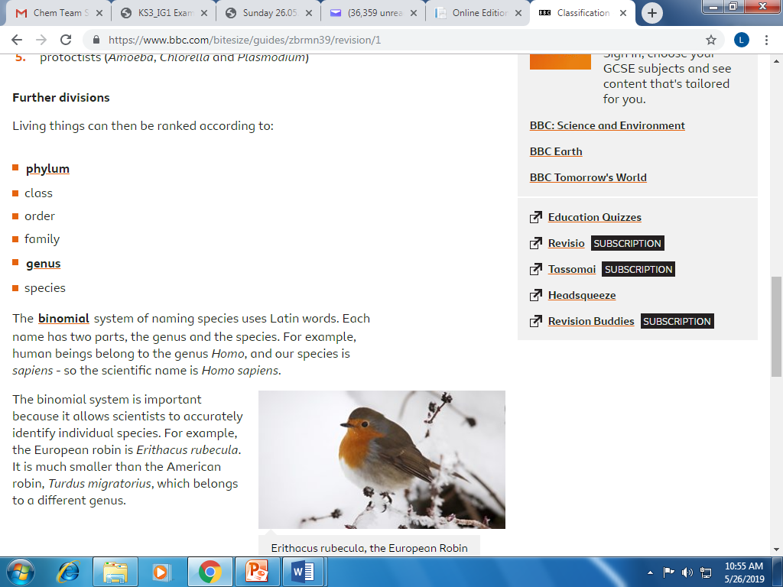
Nitrogen cycle
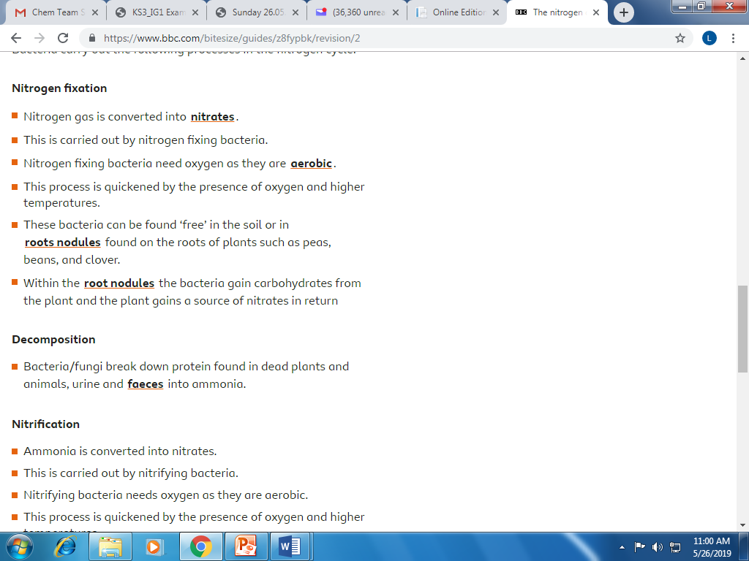

Cells
Q1.
Figure 1 shows an animal cell and a bacterial cell.
Figure 1
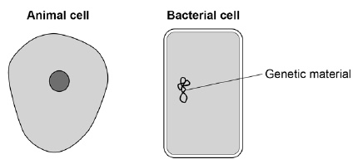
(a) Compare the structure of the cells in Figure 1.
Complete the sentences.
Choose the answers from the box.

cell membrane | cell wall | chloroplast
cytoplasm |  | nucleus
Only the animal cell contains a _________________________________________ .
Only the bacterial cell contains a _______________________________________ .
(2)
Figure 2 shows a section through a leaf.
Figure 2
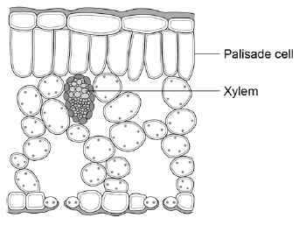
(b) The function of palisade cells is to photosynthesise.
Describe one way palisade cells are adapted to carry out their function.
___________________________________________________________________
___________________________________________________________________
(1)
(c) Complete Table 1 to show whether each structure is a tissue, an organ or an organ system.
Tick one box for each structure.

Table 1
Structure | Tissue | Organ | Organ system
Leaf
Xylem
Roots, stem and leaves
(2)
A student observed palisade cells using a microscope.
The microscope had four objective lenses, each with a different magnification.
(d) Which objective lens should the student use first?
Tick one box.
Give a reason for your answer.

×4 magnification
×10 magnification
×40 magnification
×100 magnification
Reason ____________________________________________________________
___________________________________________________________________
(2)
The student measured the width of 5 different palisade cells at a total magnification of ×400
(e) Eyepiece lenses are usually ×5 or ×10 magnification.
What combination of eyepiece and objective lenses would give a total magnification of ×400?
Eyepiece lens ____________________
Objective lens ____________________
(1)
(f) Table 2 shows the student’s results.

Table 2
Cell | Width of cell image in mm
1 | 12
2 | 13
3 | 16
4 | 10
5 | 11
(f) Calculate the mean width of the palisade cell images.
___________________________________________________________________
___________________________________________________________________
Mean width = ____________________ mm
(1)
(g) Calculate the real width of a palisade cell.
Use the mean width you calculated in part (f).
Use the equation:
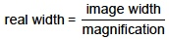
___________________________________________________________________
___________________________________________________________________
Real width = ____________________ mm
(2)
(Total 11 marks)

Classification
Q1.
All living organisms are classified into groups.
Table 1 shows the classification of one species of wheat.
Table 1

Kingdom | Plant
Phylum | Angiosperms
Class | Monocotyledons
Order | Commelinids
Family | Poaceae
Genus | Triticum
Species | spelta
(a) What is the binomial name for the wheat in Table 1?
Tick one box.

Angiosperm monocotyledons
Poaceae triticum
Species spelta
Triticum spelta
(1)
Modern classification systems compare the similarity between the DNA of organisms.
The more similar the DNA code, the more closely the organisms are related.
Table 2 shows DNA codes in five different organisms.
Table 2

 | DNA Codes |  |  |  |  |  |  |  |  | Number of differences in DNA code compared with the human sequence
Human | A | B | C | D | E | F | G | H | I
Pig | J | F | C | D | E | F | G | H | I
Wheat | C | I | K | D | M | F | G | H | I
Yeast | C | I | K | D | L | M | G | H | I | 5
Chicken | J | F | C | D | M | F | G | H | I | 3
(b) Complete the final column of Table 2 for Pig and for Wheat.
(1)
(c) Which organism in Table 2 appears to be most closely related to humans?
___________________________________________________________________
(1)
(d) Give one reason why conclusions about the similarities between organisms should not be made using only the DNA codes in Table 2.
___________________________________________________________________
___________________________________________________________________
(1)

Ecology
Q1.
Every year scientists have recorded the date when migrating birds arrived at summer breeding grounds in the UK.
The records show that for every 1 °C increase in mean global temperature, the birds arrived one day earlier.
(a) What will the birds be competing for when they arrive at their UK breeding grounds?
Tick two boxes.

Eggs
Food
Light
Mates
Oxygen
(2)
(b) Birds that arrive early might survive better than birds that arrive later.
Suggest one reason why.
___________________________________________________________________
___________________________________________________________________
(1)
(c) Global temperatures are increasing every year.
This is because of an increase of greenhouse gases in the atmosphere.
Name one greenhouse gas.
___________________________________________________________________
(1)
(d) Global warming affects the migration of animals.
Give one other effect of global warming.
___________________________________________________________________
___________________________________________________________________
(1)
(e) Which two human activities cause global warming?
Tick two boxes.

Burning fossil fuels
Eating vegetables
Farming cows
Turning off lights
Using too much water
(2)
(f) Which gas in the atmosphere causes acid rain?
Tick one box.

Carbon monoxide
Oxygen
Ozone
Sulfur dioxide
(1)
(Total 8 marks)

Nutrient cycles
Q1.
The figure below shows the carbon cycle.
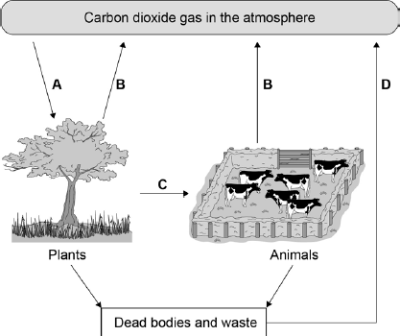
Use the information from the figure above to answer the questions.
(a) In process A, carbon dioxide in the atmosphere is taken into plants.
What is process A?
Tick one box.

Evaporation
Fossilisation
Photosynthesis
Respiration
(1)
(b) In process B, carbon dioxide is released from plants and animals into the atmosphere.
What is process B?
Tick one box.

Burning
Feeding
Photosynthesis
Respiration
(1)
(c) In which process is carbon passed from one organism to another?
Tick one box.

A
B
C
D
(1)
(d) What will happen to the concentration of carbon dioxide in the atmosphere if lots of trees are cut down?
___________________________________________________________________
___________________________________________________________________
(1)
(e) Greenhouse gases cause global warming.
Carbon dioxide is a greenhouse gas.
Name two other greenhouse gases.
1. _________________________________________________________________
2. _________________________________________________________________
(2)
(f) When living organisms die the dead material decays and is broken down.
The process of decay returns carbon dioxide to the atmosphere.
What type of organism causes decay?
___________________________________________________________________
(1)
(Total 7 marks)

More C- cycles
Q1.
This question is about carbon.
The graph shows the mass of carbon added to and removed from the atmosphere each year.
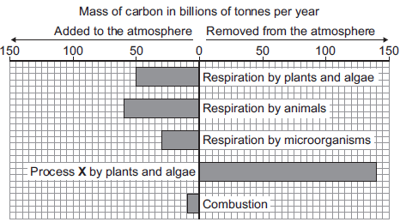
(a) Name process X.
___________________________________________________________________
(1)
(b) (i) Calculate the mass of carbon added to the atmosphere by respiration per year.
Answer = ____________________ billion tonnes
(1)
(ii) Some scientists are concerned that the mass of carbon in the atmosphere is changing.
How does the data in the graph support this idea?
______________________________________________________________
______________________________________________________________
(1)
(Total 3 marks)
Q2.
In this question you will be assessed on using good English, organising information clearly and using specialist terms where appropriate.
The diagram shows part of the carbon cycle.
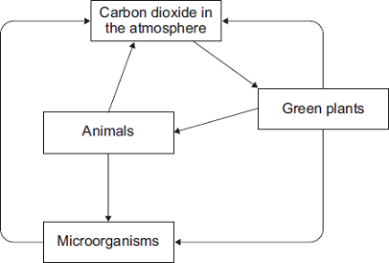
Describe how living things are involved in the constant cycling of carbon.
_______________________________________________________________________
_______________________________________________________________________
_______________________________________________________________________
_______________________________________________________________________
_______________________________________________________________________
_______________________________________________________________________
_______________________________________________________________________
_______________________________________________________________________
_______________________________________________________________________
_______________________________________________________________________
_______________________________________________________________________
_______________________________________________________________________
_______________________________________________________________________
_______________________________________________________________________
_______________________________________________________________________
_______________________________________________________________________
_______________________________________________________________________
(Total 6 marks)

Nitrogen cycle
Online learning:
Access these web pages or any other relevant websites e.g. YouTube etc.
https://study.com/academy/practice/quiz-worksheet-steps-of-the-nitrogen-cycle.html

www.marion.kyschools.us/userfiles/89/nitrogen%20cycle%20w%20questions.docx

https://study.com/academy/practice/quiz-worksheet-steps-of-the-nitrogen-cycle.html
https://studylib.net/doc/7323032/nitrogen-cycle-questions

